

DEPARTMENT OF BASIC SCIENCE AND HUMANITIES

INSTITUTE OF ENGINEERING AND MANAGEMENT, KOLKATA

**“FILE MANAGEMENT SYSTEM”**

**Submitted by:-**

**Name of the Student:** Soumyo Mallick

**Enrolment Number:** 12022002016054

**Registration Number:** 221040110434

**Section:** D

**Class Roll Number:** 67

**Stream:** Computer Science Engineering(AIML)

**Subject:** Programming for Problem Solving

**Subject Code:** ESC-103 (Pr)

Under the supervision of:**Prof. Swarnendu Ghosh**

**Academic Year: 2022-26**

(PROJECT REPORT SUBMITTED IN FULFILLMENT OF THE REQUIREMENTS FOR THE SECOND SEMESTER)



**CERTIFICATE OF RECOMMENDATION**

We hereby recommend that the project prepared under our supervision by **Soumyo Mallick**, entitled **“File Management System”** be accepted in fulfillment of the requirements for the degree of fulfillment of the second semester.

|  |  |
| --- | --- |
| _____________________________ | _____________________________ |
| Head of the Department | Project Supervisor |
| IEM, Kolkata | Basic Science and Humanities |

# Introduction:

This project is assigned to me for developing a File Management System with the help of basic C programming language.

The primary goal of the task is to create a file control device where we need to position up simple files and contents of the various files and thereby with the help of c programming, we have to create a portal (.Txt document) for adding new files, searching documents, deleting documents, editing them and in the end seeing all of the files at a look.

# Variable Description:

The different variables used in this project are listed under:-

1. int- To store integer datatypes.
2. char- To store character datatypes.
3. Array- To store the files altogether

# Function Description:

The different functions (structures) used in this project are listed under:-

1. File - For storing the required file details *vis. Contents of the file*

# Programs:

**File Management System.c**

#include <stdio.h>

#include <stdlib.h>

struct file {

char name[50];

int size;

};

void addFile(struct file *files, int *count) {

printf("Enter file name: ");

scanf("%s", files[*count].name);

printf("Enter file size (in KB): ");

scanf("%d", &files[*count].size);

(*count)++;

printf("File added successfully!\n");

}

void modifyFile(struct file *files, int count) {

if (count == 0) {

printf("No files found!\n");

return;

}

char filename[50];

printf("Enter the name of the file to modify: ");

scanf("%s", filename);

for (int i = 0; i < count; i++) {

if (strcmp(files[i].name, filename) == 0) {

printf("Enter new file size (in KB): ");

scanf("%d", &files[i].size);

printf("File modified successfully!\n");

return;

}

}

printf("File not found!\n");

}

void deleteFile(struct file *files, int *count) {

if (*count == 0) {

printf("No files found!\n");

return;

}

char filename[50];

printf("Enter the name of the file to delete: ");

scanf("%s", filename);

for (int i = 0; i < *count; i++) {

if (strcmp(files[i].name, filename) == 0) {

for (int j = i; j < (*count) - 1; j++) {

strcpy(files[j].name, files[j + 1].name);

files[j].size = files[j + 1].size;

}

(*count)--;

printf("File deleted successfully!\n");

return;

}

}

printf("File not found!\n");

}

void displayFiles(struct file *files, int count) {

if (count == 0) {

printf("No files found!\n");

} else {

printf("File List:\n");

printf("----------------------------------------------------\n");

printf("Name\t\tSize (KB)\n");

printf("----------------------------------------------------\n");

for (int i = 0; i < count; i++) {

printf("%s\t\t%d\n", files[i].name, files[i].size);

}

printf("----------------------------------------------------\n");

}

}

int main() {

struct file files[100];

int count = 0;

int choice;

while (1) {

printf("\nFile Management System\n");

printf("1. Add File\n");

printf("2. Modify File\n");

printf("3. Delete File\n");

printf("4. Display Files\n");

printf("5. Exit\n");

printf("Enter your choice: ");

scanf("%d", &choice);

switch (choice) {

case 1:

addFile(files, &count);

break;

case 2:

modifyFile(files, count);

break;

case 3:

deleteFile(files, &count);

break;

case 4:

displayFiles(files, count);

break;

case 5:

printf("Exiting File Management System.\n");

exit(0);

default:

printf("Invalid choice! Please try again.\n");

}

}

return 0;

}

# Outputs:

Sample outputs (screenshots) to demonstrate the functionalities in programs are listed below.

1. Adding a file…

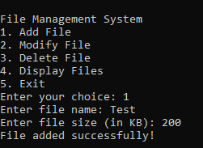

1. Modify The file

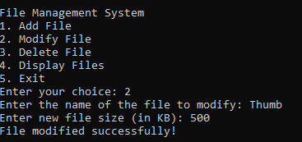

1. Delete the File

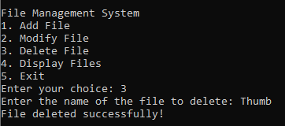

1. Display The File

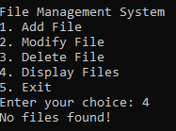

**THANK YOU!!**